Troop 999
Eagle Scout

Court of Honor

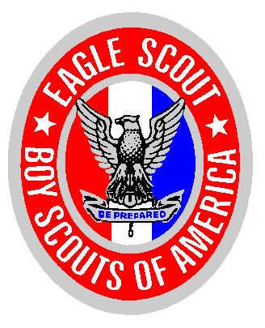

You and your family are cordially invited to attend the Eagle Court of Honor Ceremony for:

Your Son’s Name

Sunday, February 30th from 3:30pm – 5:00pm
American Martyrs Church, Blessed Kateri Room
624 15th Street, Manhattan Beach

RSVP’s are NOT necessary. This is a great opportunity for younger scouts to learn about the trail to Eagle. Please contact Your Name, 310/555-1212 if you have any questions.

